Motivators: The Regulatory Motivator

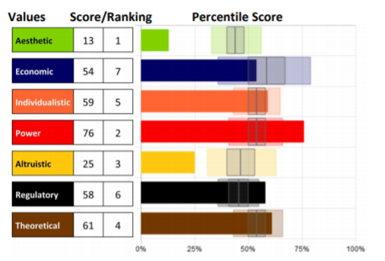
Knowing our specific level of
motivation can be crucial to
helping us understand what
drives our beliefs and actions
so we can bring them into
alignment.

Remember that although we
can explore each motivation individually, they cannot be separated. They can only be distinguished; however, all
motivators integrate to influence us.

The Regulatory Motivator – the drive to establish order, routine
and structure

This motivation indicates a need to establish order, routine and
structure. High scores in this motivation promote a black and white
mindset and a traditional approach to problems and challenges
through standards, rules, and protocols. They may be more
narrow-minded in their thinking, preferring proven methods and
concrete solutions. Lower scores are much more flexible and accept
that there are many ways to get things done and lots of options to
reach a goal. it doesn’t matter how we do it; we just need to get it
done.

High Regulatory scores do not always indicate a person will follow the
rules; however, if a rule is broken, there will be a justification for it
(ex. the rule didn’t apply to me or I don’t think it is a necessary rule).

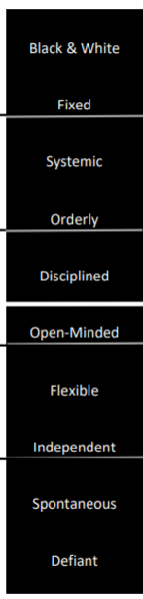
Using this descriptor scale, you can identify a key component to each person’s score in this motivation, as well as see how the scores range from Very Low to Very High, noted by the black lines between each set of descriptors. Each word represents 10 points of 100 on the scale (example: Independent people score between 20-29, Systemic people score between 70-79 in this dimension).
The white line indicates 50%, perfect balance between high and low in the motivation. Those who score closer to 50% will be situational in applying this motivator. Moving further from that line (high or low) indicates which areas are the more influential.

Whether scores are high or low, the motivators with the furthest distance above or below 50% (above or below “perfect balance” in the center) will be the highest influencers leading to the greatest impact on the decisions being made.

*Note: in this dimension, any score above 60 is a high score and anything below 40. The average range is very small.

Strengths and Limitations

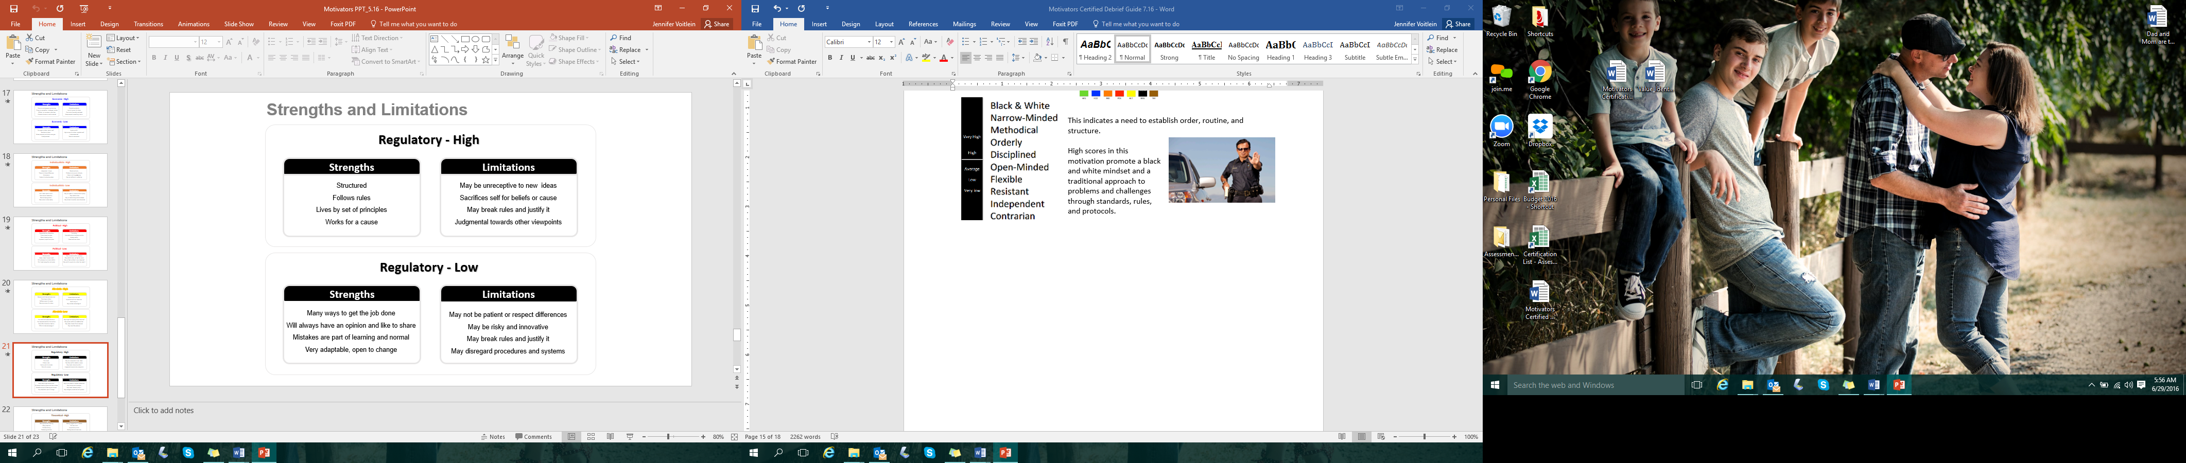

- What drives you in this motivation?
- How can that be helpful and productive for you?
- How can that limit you?

Assessments 24x7 LLC 5927 Balfour Court, Ste. 103 Carlsbad, California 92008 USA (206) 400-6647

